
Light & Engineering
Vol. 31, No. 5, pp. 153-163, 2023

https://doi.org/10.33383/2023-015 Svetotekhnika # 6, 2023

DESIGN AND DEVELOPMENT OF AN EFFICIENT, HIGH-POWER
FACTOR, LOW-COST, RGB LED SYSTEM FOR TUNEABLE
LIGHTING APPLICATION

Biswadeep Gupta Bakshi

Narula Institute of Technology, Kolkata, India E-mail: bgb.besu@gmail.com

ABSTRACTS

Branded smart red (R) - green (G) -blue (B) light emitting diode (LED) products commercial-ly available in developing countries are too cost-ly to afford for most of the population, especially for household applications. Locally manufactured cheaper alternatives of such products suffer from poor power factor and reduced circuit efficiency. To address these technical issues, a smart RGB LED system is presented here which offers high in-put power factor, good circuit efficiency, and at the same time lower fabrication cost and user-friend-ly control interface. The unique features of the pro-posed system are the front-end AC/DC converter is a constant-voltage, multiple-output flyback con-verter that mitigates the need of multiple drivers and inductors. The second is that the same convert-er is operated in discontinuous conduction mode to achieve a high input power factor. The third is that for dimming and colour tuning, pulse width modulation (PWM) control of the MOSFET switch-es is accomplished by an Arduino Mega 2560 mi-crocontroller instead of other costlier and more sophisticated options. And the fourth is that the microcontroller gets its command signal from a smartphone or computer through an HC-05 Blue-tooth module. Through laboratory testing, it is con-firmed that the LED system offers close-to-unity in-put power factor (0.928-0.985) and high efficiency of (88.14-95.46) % for a wide range of colour and luminous intensity. A comparative study reveals that the developed system is a better option than the
earlier reported prototypes ofmulticolour LED sys-tems in terms of the bill of material, economy, pow-er factor, and efficiency.
Keywords: Arduino, colour tuning, flyback con-
verter, LED driver, RGB LED, smart lighting

1. INTRODUCTION

In the present times, light emitting diodes
(LEDs) are serving the illumination needs in every avenue of human activities. Apart from very high luminous efficacy and the longest burning hour, an-other key reason behind the widespread acceptance and application of LEDs is their easy tunability [1]. In tuneable LED lighting the colour appearance and illuminance of the scene can be changed as per the visual and biological preferences of the occupants
[2]. A tuneable LED module can be formed by dif-ferent combinations of multi-colour LED chips [3]. Most of the commercially available tuneable LED module uses either the combination of cool white
(CW) — warm white (WW) LEDs [4, 5] or the com-bination of rcd-green-blue (RGB) LEDs [6, 7]. It is reported that compared to the CW-WW combina-
tion, the RGB combination offers much more flex-ibility and greater control of the spectral content of emitted light [8, 9]. The large gamut of colour pro-duced by RGB LEDs is suitable for general, dec-
orative, recreation, and back-lighting applications. Philips Hue™ [10] was the first commercial prod-uct of its kind to use RGB LEDs for smart indoor
lighting. Nowadays similar products are available from other manufacturers as well. These commer-

153

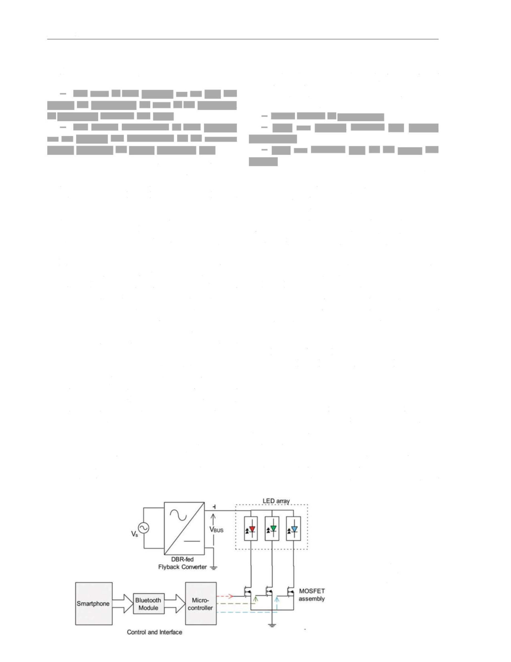
Light & Engineering
— Lesser number of components;
— Only one coupled inductor (i.e. flyback
transformer);
— Only one feedback loop for the output bus
voltage.

Vol. 31, No. 5

cial RGB LED systems possess the following two major downsides:
— The costs of such products are too high and
beyond the affordability for most of the population of developing countries like India;
— The control mechanisms of such products
are too complex and cumbersome for the common
people, especially the elderly population [11].
The above two issues can be addressed by in-corporating cheaper components and simpler con-trol interfaces as done in the locally-manufac-tured non-branded RGB LED systems. But in these endeavours, the aspects of circuit efficiency and input power factor are often ignored. As a re-
sult, these non-branded RGB LED products suffer from poor circuit efficiency and poor input pow-er factor.
In the present work, the above-mentioned sci-entific problem is solved by developing a low-cost smart RGB LED system with a user-friendly control
interface, high input power factor, and good circuit
efficiency. To cut down the fabrication cost of the
system, firstly, the familiar and economic microcon-troller Arduino Mega 2560 [12] is used as the heart of the system instead of more sophisticated and costlier alternatives [9, 13-14]. Secondly, the mi-crocontroller is communicated from a smartphone or computer via one HC-05 Bluetooth module, which costs only 2.5 S [15]. The overall fabrication cost of the developed prototype is around 24.88 $, which is much lower than the similar branded prod-ucts available in the market.
While most of the earlier reported tuneable LED systems use multiple LED drivers, each one dedi-cated to individual colour LED array [3, 5, 8, 16]; in this work, a single LED driver with galvanic isolation and multiple constant-voltage outputs is

designed and implemented based on parallel load branch flyback converter topology [17]. The LED driver with such a multiple-output design offers the following technical advantages:

Because of the above three reasons, not only the cost of the system is cut down, but also the losses are reduced, and eventually the circuit efficiency is
improved, which is (88.14-95.46) %. Moreover, the judicious design of the front-end flyback converter in discontinuous conduction mode (DCM) ensures a high input power factor (0.928-0.985) per the inter-national standards [18].
The paper organization is as follows: section 2 describes the design and development procedure of the RGB LED system, section 3 elaborates the per-formance evaluation results, and section 4 presents a concise technical comparison of the developed system with the previously reported prototypes [13,
14, 19-21].

- DESIGN AND DEVELOPMENT OF THE LED DRIVER SYSTEM
2.1. Scientific Task

The scientific task of the present work is to de-velop a cost-effective smart RGB LED system with a simple control interface, high input power factor, and good circuit efficiency. The schematic represen-tation of the RGB LED system developed for this task is shown in Fig. 1, which comprises a multiple output front-end converter, the LED module, and

Fig. 1. Schematic diagram of the developed LED system

154

Light & Engineering

Vol. 31, No. 5

Table 1. Parameters of the RGB Power LEDs

Parameter | Values for constituent LED chip
Parameter | Red | Green (3 | Blue (8)
Rated forward current | - mA | - mA | - mA
Rated forward voltage | 2.9 V | 3.8 V | 3.8 V
Rated power | 1 W | 1 W | 1 W
Rated luminous flux | 80 Im | 45 Im | 40 Im
External current limiting resistor | 11 Q | 々：2 c | O：2 C

the MOSFET switch assembly; and the control sys-tem and its interface. The key features of the pro-posed system are
— There is a single LED driver with a single
coupled inductor (i.e. flyback transformer) and three constant voltage outputs, each for R, G, and 5 LED
arrays;
— The front-end converter is designed to be a
DCM flyback converter for better input power fac-tor and smaller magnetic part;
— The heart of the control system is the eco¬
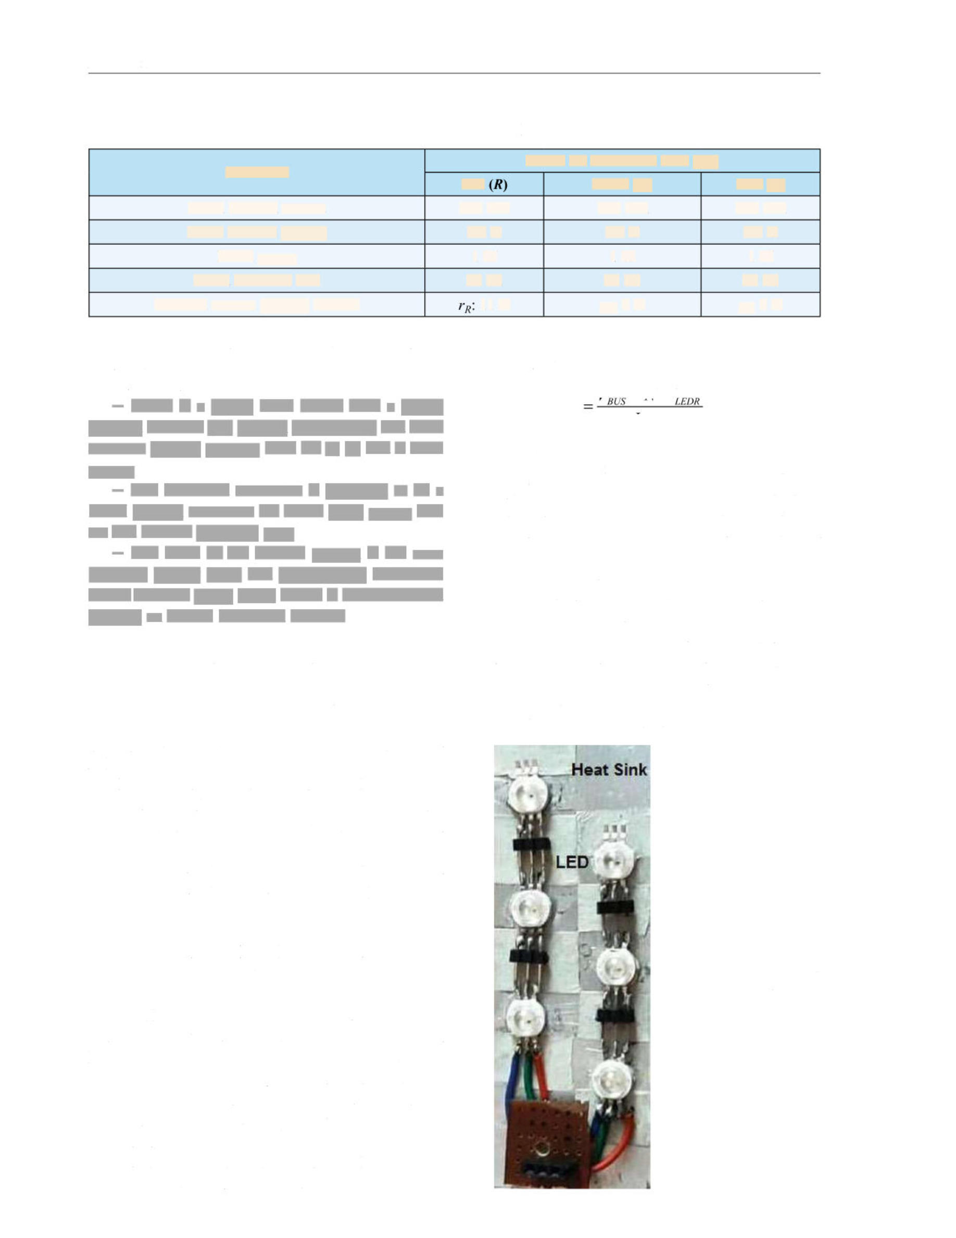
nomical, widely used, and user-friendly microcon- \xoWqv Arduino Mega 2560, which is communicated through an HC-05 Bluetooth module.
voltage output(腺 computed by (1).
Values of these resistors are
- -N -V
，
仆 (1)
1LEDR

where Rext is the current limiting resistor, VBUS is the constant DC output voltage of the fronr-end con¬
verter, N is the number of LEDs connected in se¬ ries in each string, VLEDR is the rated forward volt¬ age of an LED chip,"edr is the rated current of an LED chip.
Relevant design parameters of the LED module arc tabulated in Table 1, and its electrical equiva¬ lent circuit is shown in Fig. 3. The cathode ends of same-colour strings are shorted together. In series with the three such short-circuited terminals, three
fast-switching IRFZ44N MOSFETs [22]
are connected as dimming switches. The MOSFET assembly photo is shown in Fig. 4. The duty ratio
Fig. 2. Arrangement of the LED chips on the heat-sink

2.2. Operation of the System

The AC voltage 匕is converted into a constant DC bus voltage, VBUS by the diode-bridge rectifier
(DBR) fed flyback converter. Arrays of R, G, and B LEDs are connected across this constant volt-age DC bus in parallel to each other. In the cath-ode end of each LED array, one MOSFET switch is connected in series for dimming and colour control
functions. The gate terminals of these MOSFETs are controlled by the microcontroller unit, which is commanded by either a smart mobile phone or a
computer.

2.3. Design of the LED Module and the MOSFET Assembly

6-pin RGB power LEDs procured from the lo-cal market are used to build the LED module. Each LED houses three electrically independent chips of different colours (/?, G, 8) with total rated watt-age of 3 W. Six such LEDs are placed over an alu-minium heat sink in a (2x3) array combination, as shown in Fig. 2. Current-limiting resistors are con-nected in series with each branch ofthe LED to lim-it the current when connected across the constant

155

Light & Engineering

Fig. 4. Photo of the MOSFET assembly

2%MVbusIledr

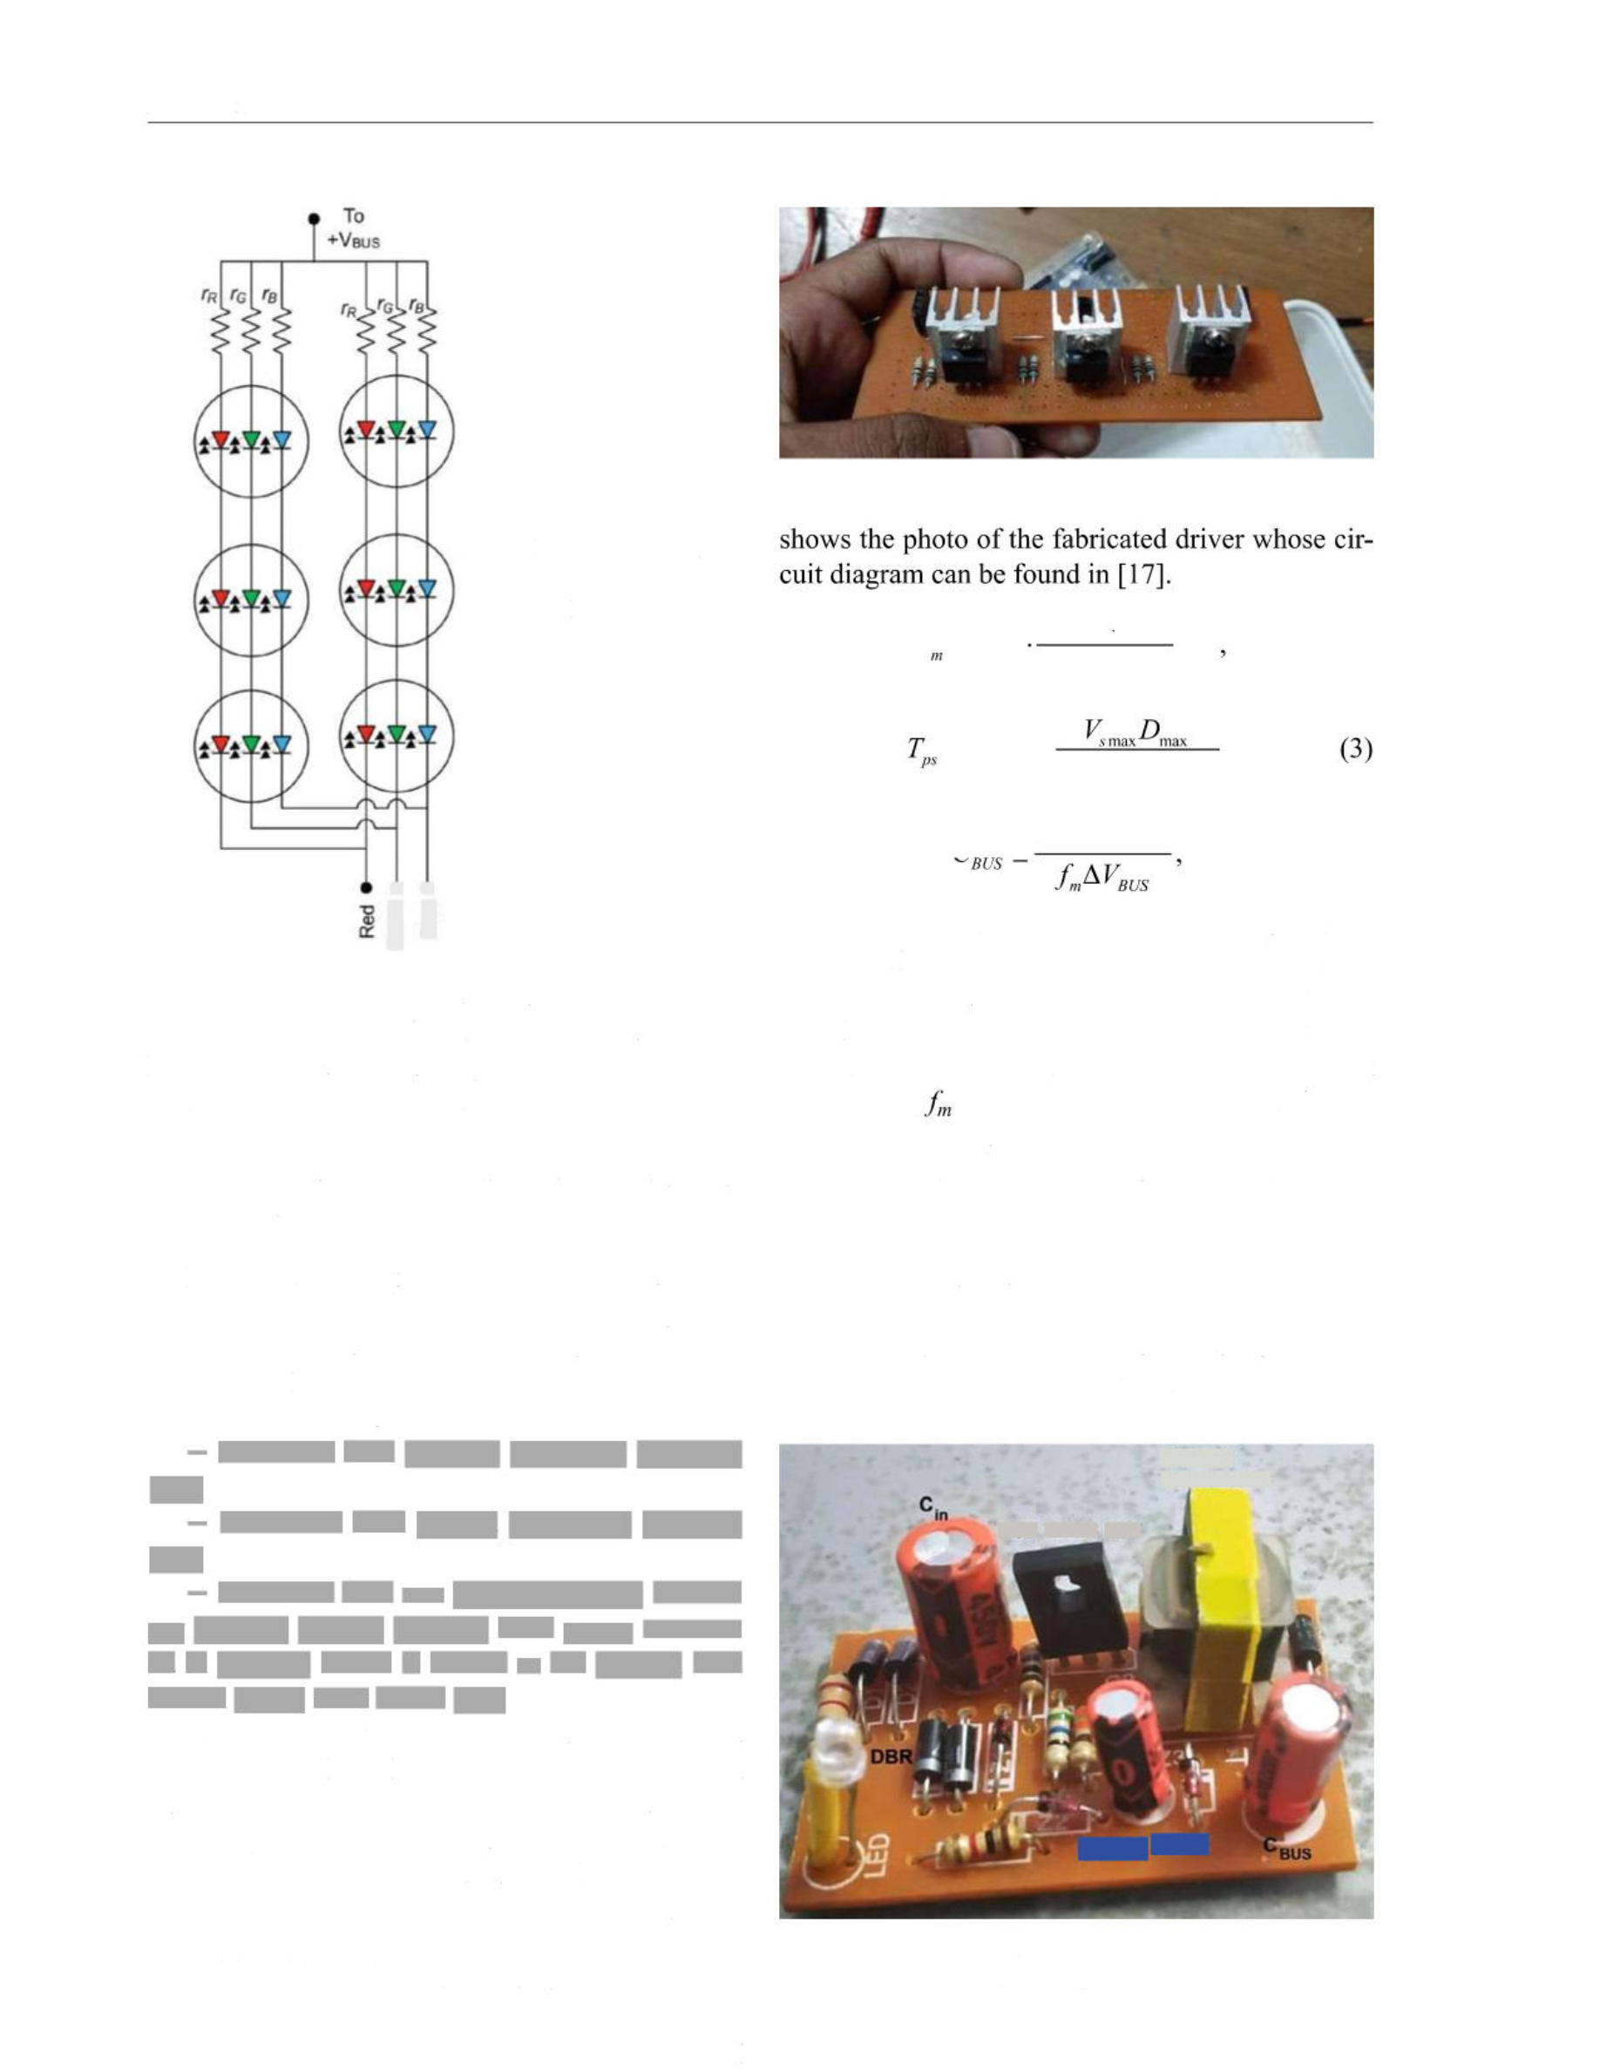
Vol. 31, No. 5
片 p2
£ =0.81 ‘mm max (2)
Fig. 3. Electrical equivalent circuit of the LED module
七〃s(l-4ax)'
= 0.9"

「 > DgMlledr (4)
MJE 13003 BJT
NC<71002

Fig. 5. Fabricated diode-bridge rectifier (DBR) fed flyback converter
coffo lm

••

of the gate pulses obtained from the microcontrol-ler determines the ON and OFF duration of these
MOSFETs, and this, in turn, determines the colour and intensity of the emitted light.

2.4. Design of the Parallel Load Branch (PLB) Flyback Converter

DBR-fed flyback topology is selected as the front-end converter because of its lower cost, high-er efficiency, and galvanic isolation [23, 24]. For multicolour LED lighting applications, three possi-ble versions of such converter are possible, viz.
— Converter with multiple secondary windings
[20];
— Converter with tapped secondary winding
[25];
— Converter with one constant-voltage second¬
ary winding feeding multiple LED arrays connect-ed in parallel, which is named as the parallel load branch (PLB) LED driver [17].
A recent study [17] has shown that the third one that is the PLB LED driver is the best option in terms of efficiency, power factor, and econo-
my. And, hence, it is chosen in the present work. The converter is operated in DCM to achieve a high-power fheto匚 Using the following design equa-tions (2) - (4), the power circuit parameters of the driver are estimated and listed in Table 2. Fig. 5

where Vsmax and Vsmin are the maximum and the minimum RMS supply voltage, respectively; D〃1ax is the maximum duty ratio of the converter under DCM (<0.5); Tps is the primary-to-secondary turns
ratio; Lm is the mutual inductance of the flyback
transformer; is the switching frequency; M is the number of parallel connected LED strings; ^VBUS is the maximum ripple content in the output voltage; Cbus is the output capacitor of the converter.

2.5. Control and Interface

Arduino Mega 2560 board based on ATmega 2560 microcontroller [12] is used as the controller

Flyback transformer

156

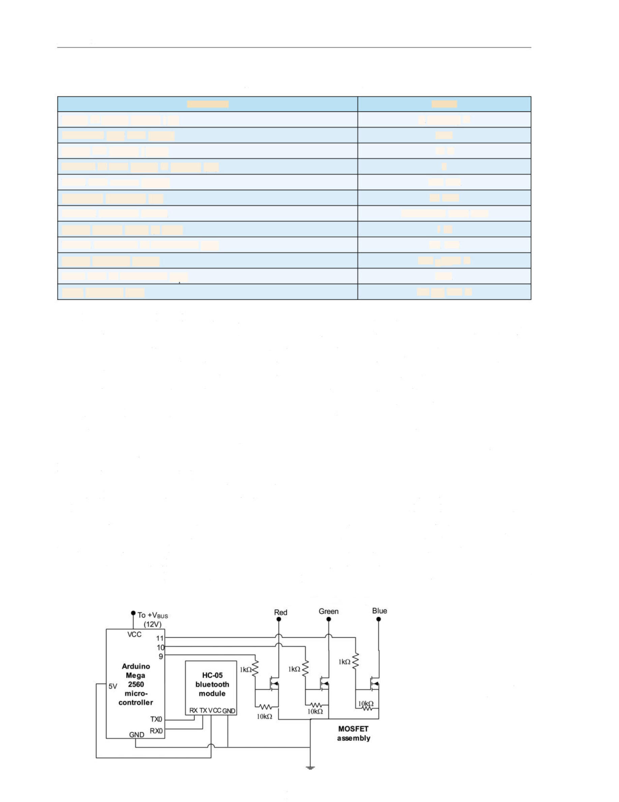
Light & Engineering

Vol. 31, No. 5

Table 2. Design Parameters of the Flyback Converter

Parameter | Values
Range of supply voltage (R) | (180-250) V
Maximum duty ratio (Dmax) | 0.45
Output bus voltage (KBUS) | 12 V
Number of LED strings in parallel(M) | 6
Rated LED current (/ledr) | - mA
Switching frequency 仇) | - kHz
Selected electronic switch | MJE\30G3 NPN BJT
Output voltage ripple (J腺us) | 1 %
Mutual inductance of transformer 区口) | 2.1 mH
Output capacitor (Cbus) | 220〃F,16 V
Turns ratio of transformer (7LS) | 22:1
Input capacitor (Cin) | 2.2 "F,450 V

unit. Microcontroller PWM pins 11, 10, and 9 are connected to the gate terminals of the MOSFETs controlling H, G, and B LEDs, respectively. %pin ofthe microcontroller is fed from the VBUS, which is practically constant at 12 V DC, and its GND pin is connected to the common ground node of the MOS-FET assembly.
An HC-05 Bluetooth transceiver module [15] is used to communicate the microcontroller from a smartphone or compute匚 The connection of the mi-crocontroller with the MOSFET assembly and the Bluetooth module is shown in Fig. 6. The flowchart for LED colour and intensity control algorithm is shown in Fig. 7, which is implemented in Ardui- no IDE.
Android mobile application 'Colour LED Con-
troller, [26] downloaded from Google Play Store is used to control the RGB LEDs. The interface of the application is shown in Fig. 8. The 'BT List9 pane displays the available Bluetooth devices.

module is paired with the smartphone at first. There-
after, the desired colour of the emitted light can be realized either by clicking on the target colour in the colour wheel or by adjusting the virtual sliders corresponding to R, G, and 5 primaries. The values shown against 7?, G, and 5 sliders indicate the rel-ative intensities of R, G, and 6 LEDs whereas the 'current colour9 bar at the top indicates the colour appearance of the emitted light.

- EXPERIMENTAL EVALUATION OF THE DEVELOPED SYSTEM

To assess the electrical and photometric perfor-mance of the developed RGB LED system, an ex-perimental set-up is prepared in the laboratory, as shown inFig. 9. A regulated AC power supply feeds the system from the nominal supply voltage (230 V, 50 Hz). A digital power meter measures the input power (Pin). The currents and voltages of the supply

(From RGB LED Module)

Fig. 6. Connection of the microcontroller with the Bluetooth module and the MOSFET assembly

157

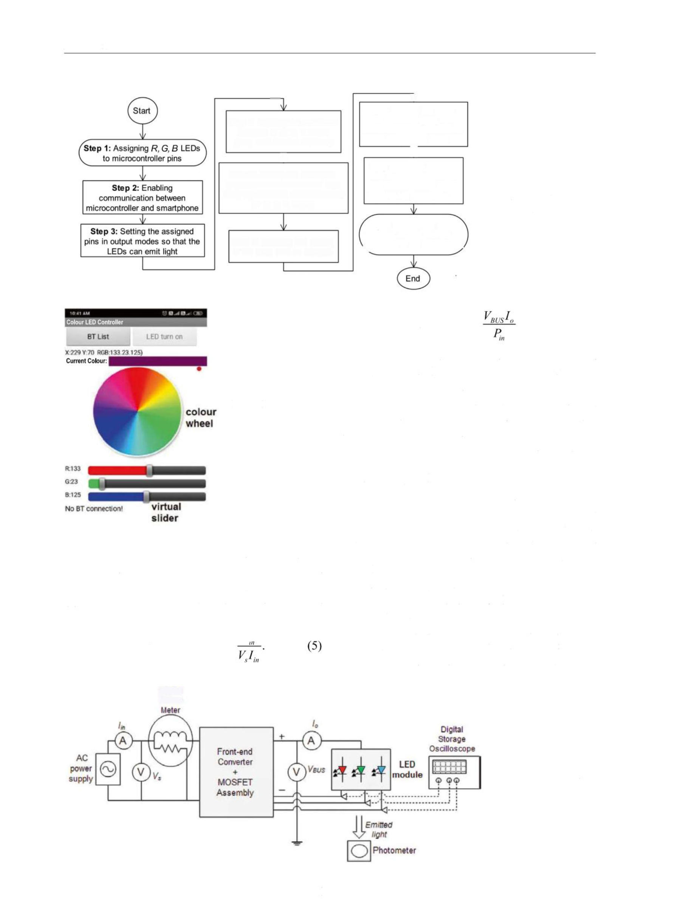
Light & Engineering

Vol. 31, No. 5

-

J
Step 5: Setting the maximum intensity of combined white light (duty cycle=100% simultaenously
for R G, B LEDs)
W
Step 7: Defining the limits of
the minimum(0%)and maximum(100%)intensities

of the R,G, 启 LEDs
Step 8: ratio of per

Step 4: Defining the maximum
intensity of R,G, B LEDs (Duty ratio =100% for each)
,
Step 9: Printing the relative intensity or duty ratio of
、
R,G,B in the monitor
J
Setting the duty
R, G, B LEDs as desired colour (user
input) of the emitted light
Fig. 7. Flowchart of the LED colour and intensity control program

Step 6: Fetching and storing of the input data as integers

Circuit Efficiency = -100 %. (6)

The pulse-width modulated voltages imposed across R, G, and B LED strings are recorded using a Techtronix 1072B digital storage oscilloscope. The illuminance of the emitted light is measured with the help of a Metravi 1300 digital luxmeter fixed at a distance of 54 cm from the LED module.
Fig. 8. Interface of the mobile application
The testing of the system is carried out in two separate modes, viz.
Inmode 1, the LED module is set to emit full-in- tensity lights of three primaries (red, green, and
blue), three secondaries (yellow, magenta, and
cyan), three intermediates (purple, pink, and lime) and white colours. Experimental data recorded in this mode are tabulated in Table 3. Sample photos of the LED module operated in this mode are fur-nished in Fig. 10, and the corresponding voltage waveforms are shown inFig. 11. Bar plots ofcircuit efficiency and input power factors at different co-lours are shown inFig. 12. It is evident fromFig. 12 that both the circuit efficiency and the input PF be-come maximum when the system emits full intensi-
side and the load side are measured by digital am¬ meters and voltmeters. The input power factor and efficiency of the circuit are obtained, thereby, using
(5) and (6), respectively, at each desired colour and intensity level.
P
Input Power Factor =

Digttal
Power

Fig. 9. Schematic of the experimental set-up

158

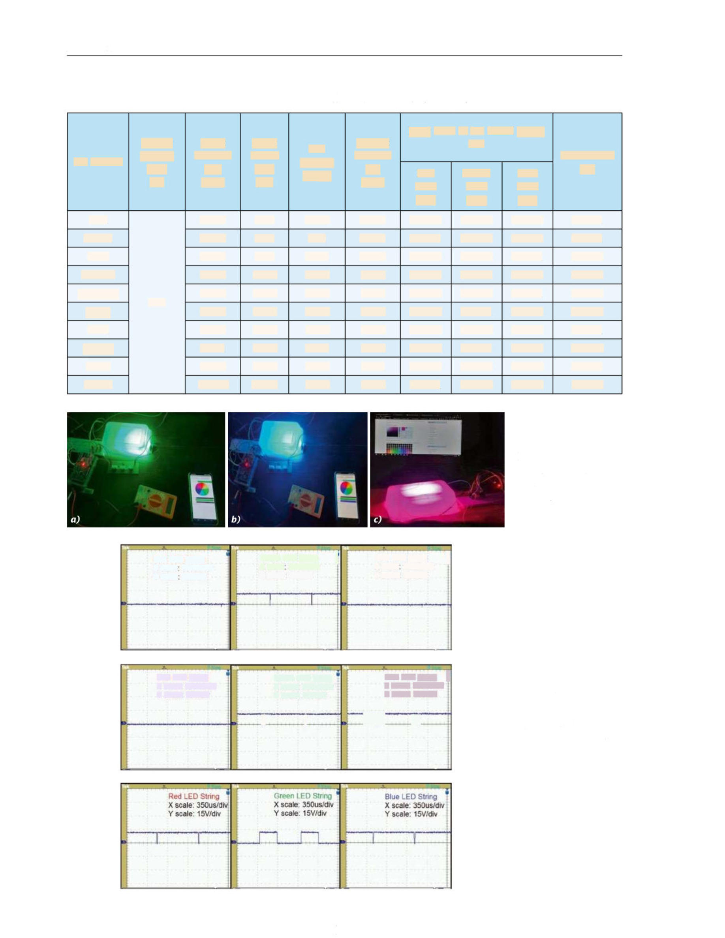
Light & Engineering
Red LED String
- scale: 350us/div Y scale: 15V/div
Blue LED Stnng f
- scale. 350us/div Y scale: 15V/div
.J_ .1
1

Vol. 31, No. 5

Table 3. Experimental Data Recorded in Mode-1

Set Colour | Supply  Voltage  (味)  (V) | Input Current  (An)  (mA) | Input Power  (%)  (W) | Bus Voltage  (/us) | Output Current  (/.)  (mA) | Duty ratio of the PWM pulses  for: |  |  | Illuminance  (lx)
 |  |  |  |  |  | Red  LED  (Dr) | Green LED  (%) | Blue LED  (%) | Illuminance  (lx)
Red | 230 | 38.78 | 8.36 | 12.14 | 0.612 | 0.9890 | 0.0110 | 0.0052 | 397.31
Green | 230 | 39.49 | 8.55 | 12.1 | 0.623 | 0.0071 | 0.9922 | 0.0095 | 226.21
Blue | 230 | 39.23 | 8.47 | 12.11 | 0.609 | 0.0068 | 0.0076 | 0.9871 | 200.44
Yellow | 230 | 70.07 | 15.62 | 12.05 | 1.212 | 0.9903 | 0.9833 | 0.0072 | 611.44
Magenta | 230 | 70.76 | 15.82 | 12.03 | 1.233 | 0.9924 | 0.0066 | 0.9881 | 587.99
Cyan | 230 | 70.34 | 15.55 | 12.02 | 1.207 | 0.0089 | 0.9811 | 0.9902 | 416.28
Pink | 230 | 74.88 | 16.84 | 11.99 | 1.322 | 0.9926 | 0.4034 | 0.7995 | 636.81
Purple | 230 | 65.11 | 14.26 | 12.01 | 1.082 | 0.5994 | 0.2011 | 0.9935 | 476.36
Lime | 230 | 76.09 | 17.19 | 11.98 | 1.361 | 0.9888 | 0.9613 | 0.3094 | 661.81
White | 230 | 100.49 | 22.79 | 11.94 | 1.822 | 0.9911 | 0.9856 | 0.9929 | 799.69

Fig. 10. Photos of the LED module emitting green (a), cyan (6), and pink (c) lights in mode-1

Red LED String  - scale 350us/div Y scale 15V/div | Green LED String [  - scale 350us/div  Y scale: 15V/div | Blue LED String  - scale 350us/div Y scale: 15V/div
f

Set colour: green

Green LED Stnng
- scale: 350us/div Y scale: 15V/div

|

Fig. 11. Waveforms of the voltages across
R, G, and B LED strings for different set colours

Set colour: cyan

Set colour: pink

159

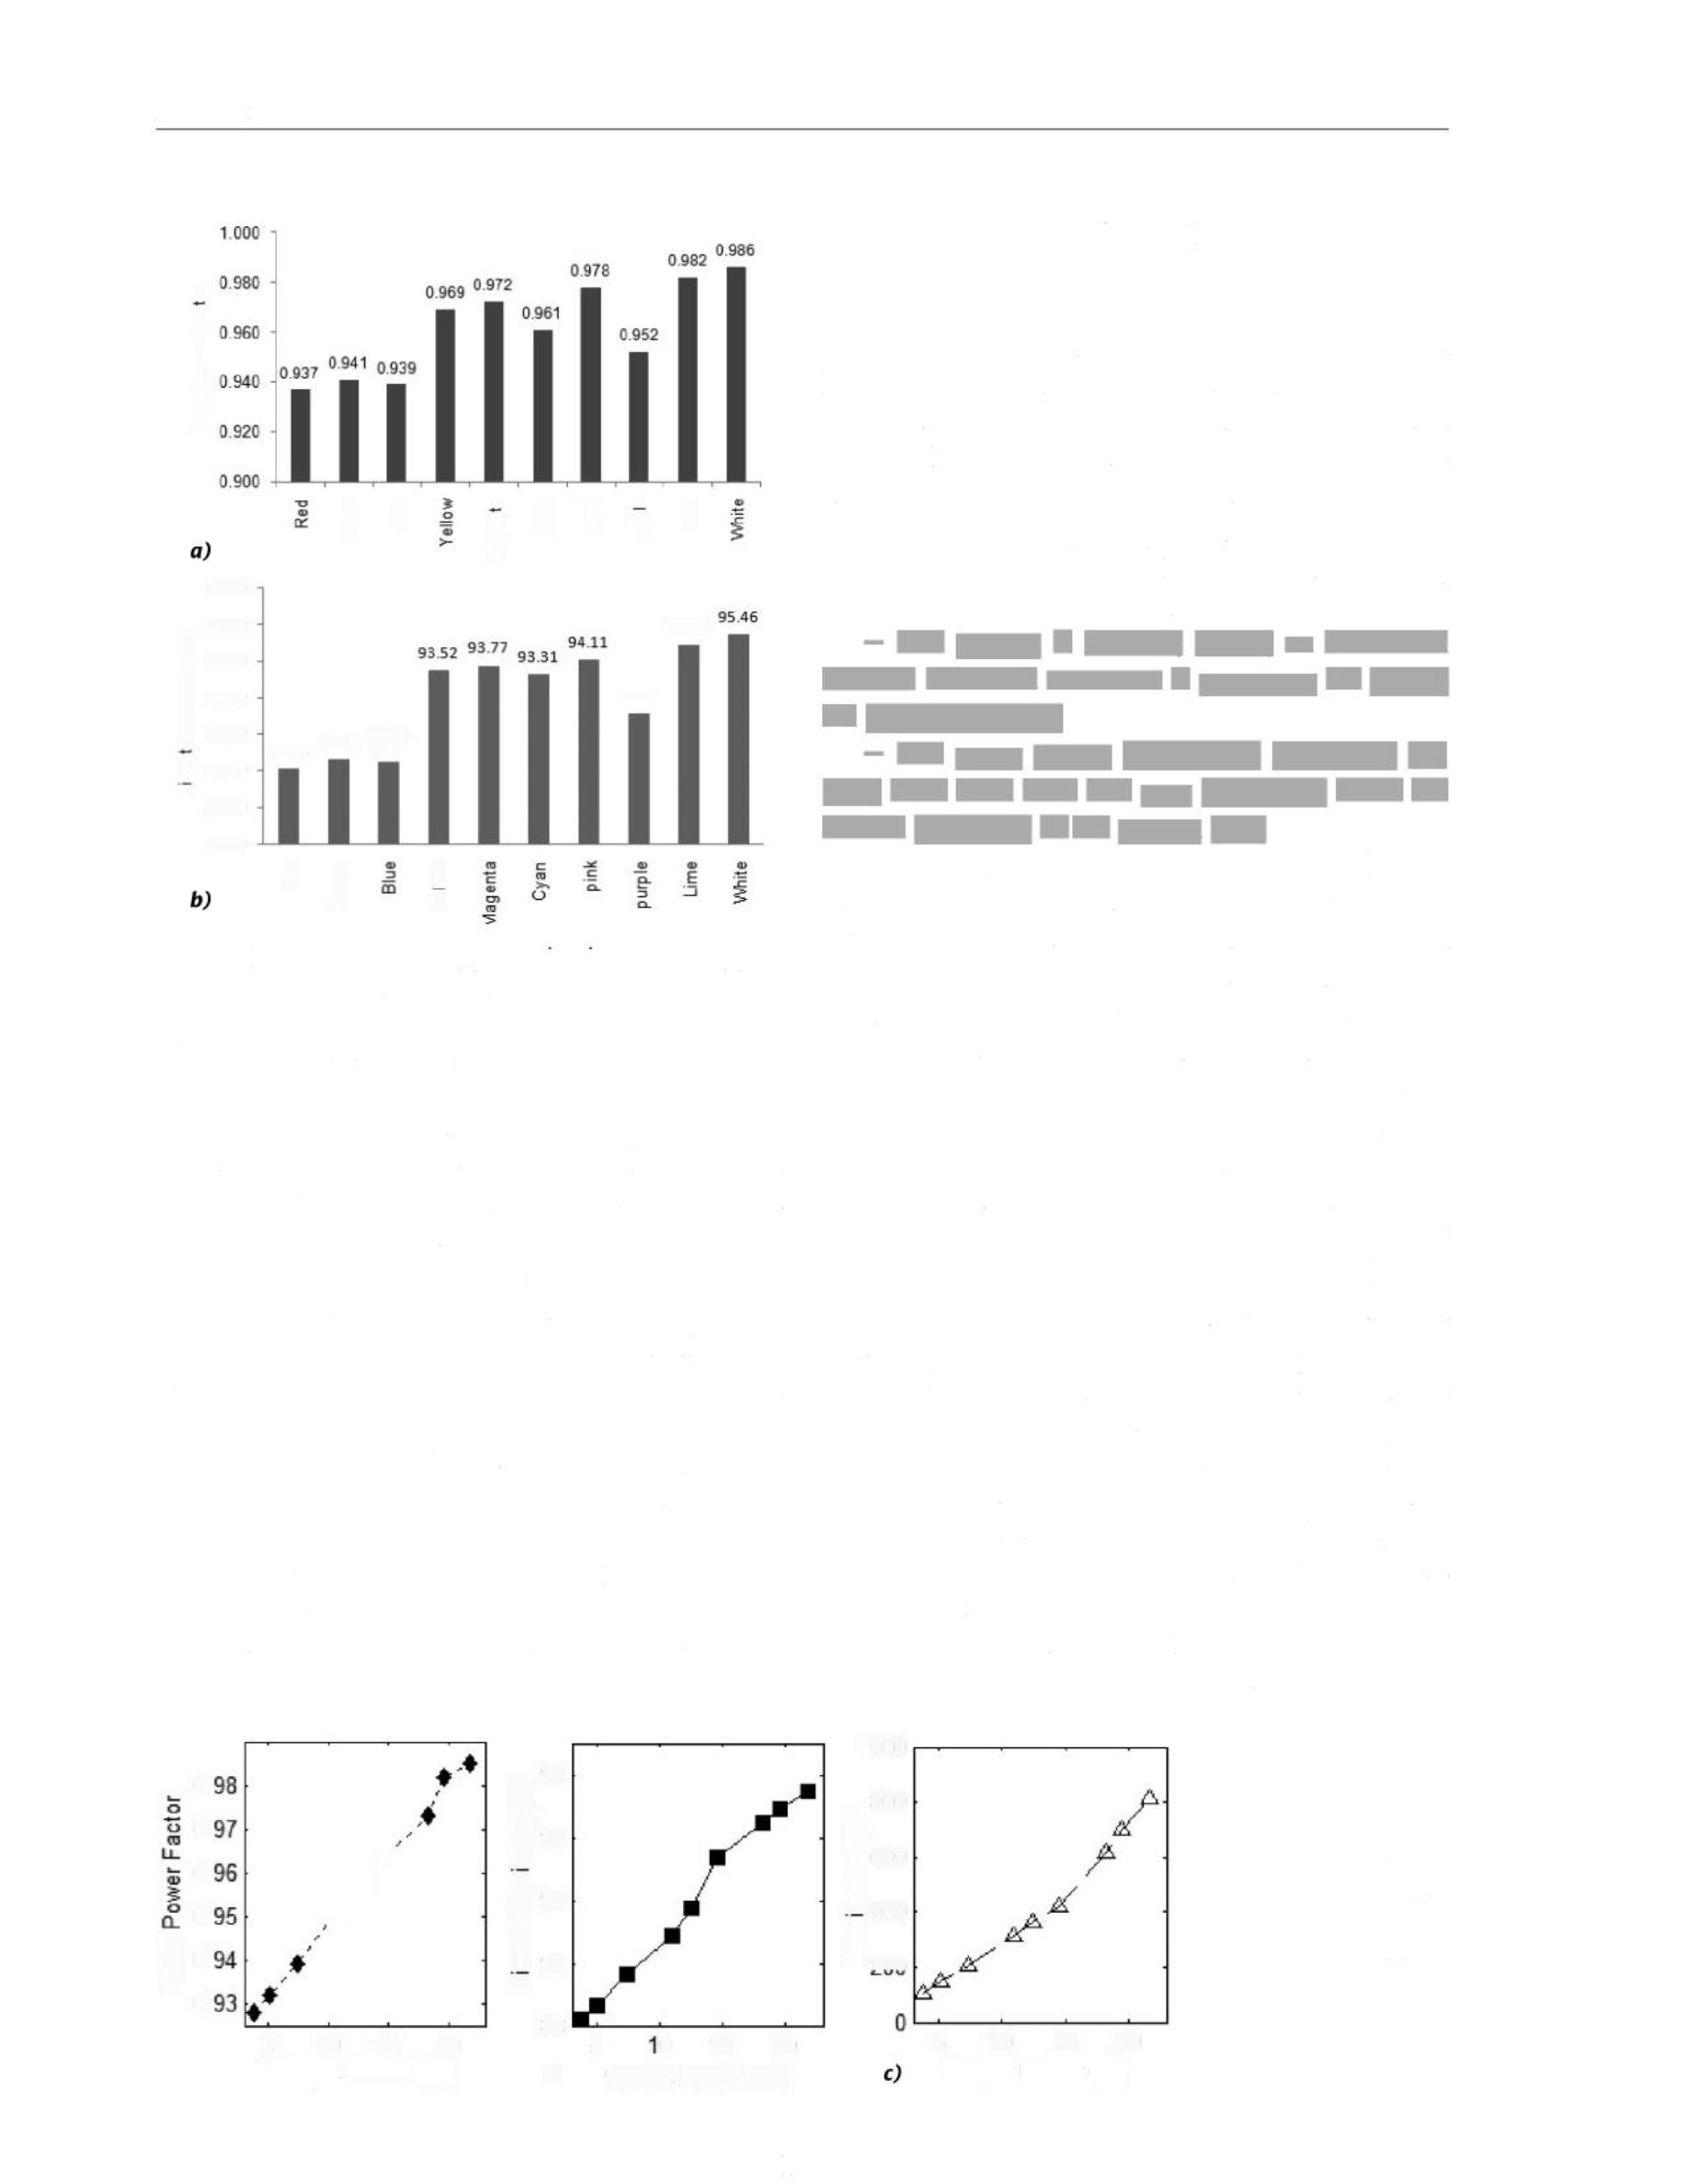
Light & Engineering

(％)
90.00
xod
-ndu-

98.00

96.00

.tu 

88.00

86.00

84.00
®
w
iij
o
s-m

88“ 365 8T斗
e c
u
e6w
ueA。
•
djnd eEn

94.87

91.13
-ndu-
o.
0.
0.
0.

0. 6

a)
岳 92
wm 90
(％) 96

o 88
”
Az 94
®。
asueu 
E
n
5 10 15 20 Output Power (W)
5 10 15 20 Output Power (W)

J♦

Vol. 31, No. 5

PE cv&o
Fig. 12. Input power factor (a) and circuit efficiency (b) of the developed system at different set colours

ty white light. In mode 1, the input power factor lies in the range of (0.937-0.986), whereas the circuit efficiency ranges within (88.14-95.46) %.
In mode-2, the output power of the LED system is gradually increased from minimum to maximum by adjusting the virtual sliders of the mobile appli-
cation. The variations of input power factor, circuit
efficiency, and illuminance with respect to the out-put power(腺us4) are plotted, as shown in Fig. 13. It is observed that as the output power is varied over the range of (3.75-21.75) W, the input PF in-creases almost linearly from 0.928 to 0.985, where-as the circuit efficiency increases from 88.22 % to 95.45 %. The rate of increment of the efficiency tends to get reduced at higher output power because of increased temperature. The illuminance increas- es from 104.75 lx to 810.42 lx following a slightly quadratic curve.

- COMPARISON WITH PREVIOUS WORKS AND COST ANALYSIS

Various technical parameters of the developed RGB LED system are compared with similar works reported earlier. The comparison is summarized in Tabic 4. Modepalli and Leila [19] have developed a 91 % efficient prototype based on single-induc- tor-multiple-output (SIMO) buck topology applica-ble for multi-colour LEDs. However, in this work, the following limitations can be found:
— The system is DC-fed, hence, an additional
AC-DC front-end converter is necessary for practi-cal implementation;
— Too many output electrolytic capacitors (03
nos.) have been used that may negatively affect the overall reliability of the system [27].
Compared to this work, the prototype of Huang et al. [20] has displayed greater efficiency (96.5 %) by implementing a unique partial power regulation
scheme. However, in this work, a flyback converter with multiple secondary windings has been used as the front-end converter which is a much costlier se-
lection. Moreover, the sizes of the three output ca-pacitors of this prototype are also larger. Zhan et al. [13] have managed to remove all the output bus ca-pacitors from their driver prototype which is signif-icant as far as the system's reliability and longevity are concerned [27]. However, the number of MOS-FET switches is greater (05 nos.) in this work which will surely increase the power loss and cost of fab-
rication. Furthermore, the prototype is DC-fed, and its efficiency has not been evaluated.
Among the recent AC-fed multi-colour LED
drivers, X. Liu et al. [21] have achieved about 91 % efficiency with a LED module of 7.2 W rated pow-
er. But as the frond-end converter, they have used a SIMO buck converter like [19] whose input power factor has not been assessed. For a lower rated pow-er (6 W) RGB LED module, P. Liu et al. [14] have

10o0 (x8o0
a

三 9nc

Fig. 13. Variation of input power factor (q), circuit efficiency (b) and illuminance (c) with output power

- o 15 20
Output Power (W)

160

Light & Engineering

Vol. 31, No. 5

Table 4. Comparison of the Present Work with the Previously Reported Prototypes

Parameter | Modepalli et al. |19| | Huang et al. |20| | Zhan et al. [13| | X.Liu et al. [21] | P.Liu et al. |14| | Present  Work
Rated input voltage | - V (DC) | - V (DC) | - V (DC) | - V (AC) | - V (AC) | - V (AC)
Rated power | 12 W | 45 W | 40 W | 7.2 W | 6W | 21.6 W
Configuration of front-end converter | Buck | Flyback with mul-tiple secondaries | Buck | Buck | Buck | Flyback with PLB
No. of active switches | 03 | 04 | 05 | 04 | 05 | 04
No. of output capac-itors and sizes | 03  4.7〃F,100  - each | 03  100^F, 50 Veach | Nil | 01  2.2〃F,50 V | 03 3000〃F,25 V; 1000〃F,25 V;  100〃F,25 V | 01,  220 "F, 16 V
Inductor size | 4.7 mH | Primary: 61.5 H  Secondaries:  4.7〃H,24.4〃H,  23.9〃H | 941 4H | 4.7 mH | 40〃H | 2.1 mH
Maximum efficiency | 91 % | 96.5% | Not measured | 90.64 % | 88.6% | 95.46 %
Minimum efficiency | Not measured | 91.3% | Not measured | Not measured | 84.5% | 88.14%
Maximum input PF | Not applicable | Not applicable | Not applicable |  | 0.965 | 0.985
Minimum input PF | Not applicable | Not applicable | Not applicable |  | 0.928 | 0.928

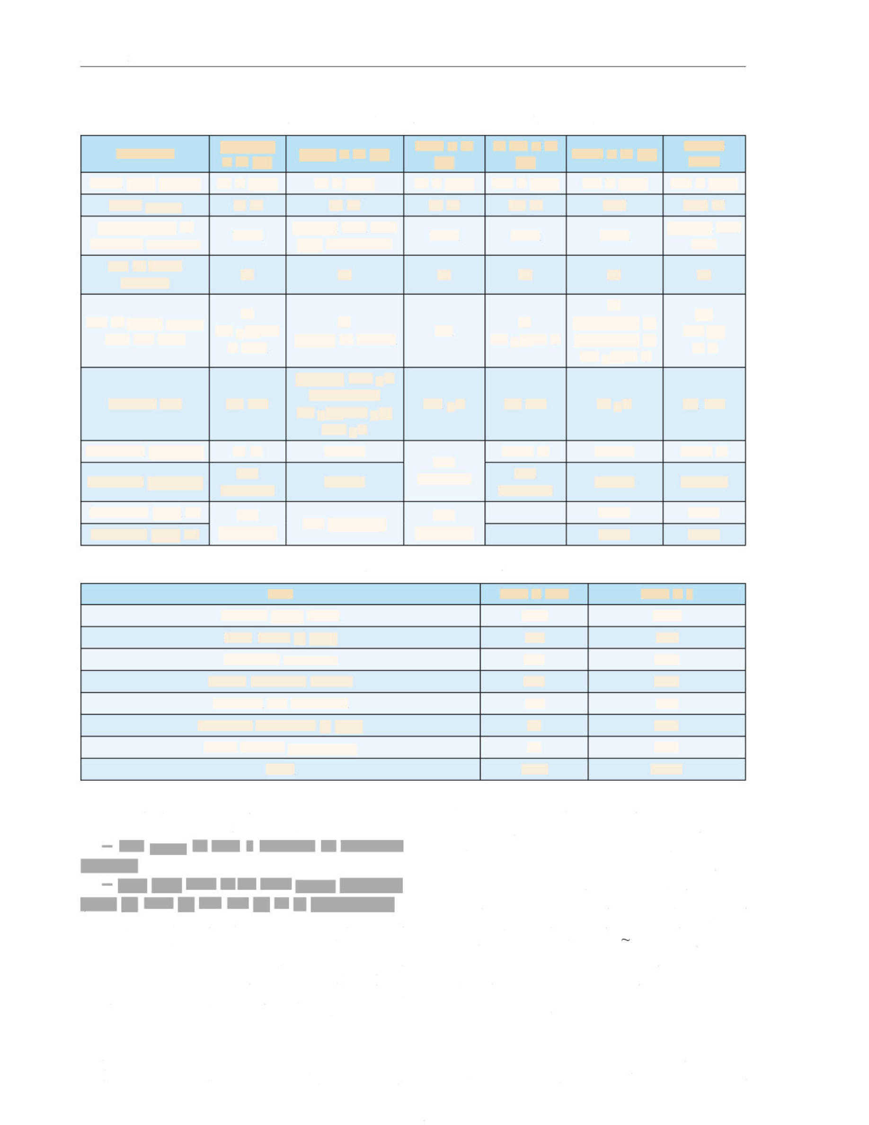
Table 5. Fabrication Cost of the Developed LED System
〃
or a 24.88 $, which is much lower than the popu¬
lar smart bulb made by Philips -2800 INR or 35 $
of similar category [10]. The cost can be further re¬ duced for a larger-scale production of the prototype.

Item | Price in INR | Price in $
Arduino Mega board | 1250 | 15.63
RGB LEDs (6 nos.) | 150 | 1.88
Front-end converter | 200 | 2.50
HC-05 Bluetooth module | 200 | 2.50
Heatsink and veroboard | 100 | 1.25
1RFZ44N MOSFETs (3 nos.) | 60 | 0.75
Other discreet components | 30 | 0.38
Total | 1990 | 24.88

developed an efficient high PF driver. However, the limitations of their work are found as
— The usage of total 5 numbers of MOSFET
switches;
— Very large sizes of the three output capacitors
(3000 gf, 1000 (if, and 100 gf, 25 V, respectively).
The present work is a trade-off between cost and flexibility and attempts to combine the upsides of the previous works. The system is compatible with AC supply as the front-end converter is a DCM fly-back converter with parallel load branches. Only one electrolytic capacitor is necessary across the output bus. The sizes of the transformer inductance and the output capacitor are also moderate. The in-put PF of the system is close to unity (0.928-0.985)

for a wide range of set colour and output power. At the same time, the efficiency of the system is bet-ter and is (88.14—95.46) %. This is than most of the earlier works. The break-up of the fabrication cost of the developed system is tabulated in Tabic 5. The total cost of fabrication is around 1990 INR

CONCLUSION

The scientific objective of this work is to de-velop a cost-effective, near-unity power factor and

161


Light & Engineering

Vol. 31, No. 5

highly efficient, smart RGB LED system with a simpler control interface which will be an alter-native to similar commercial products in develop-ing countries. Unlike most of the earlier works, the front-end power stage of the present system is a PLB multiple output flyback converter. Judicious design of such a converter has mitigated the need of multiple inductors, reduced the overall bill of ma-
terial, and minimized power losses. Moreover, the DCM operation of this converter has ensured a high input power factor. The tuning of colour and inten-sity of the produced light is performed by three ded-icated MOSFETs connected in series with R, G, and B LEDs. These MOSFETs get their command signal from an Arduino Mega 2560 microcontrol-
ler, communicated from either a smartphone or a computer pre-installed with a free Android appli-
cation. The choice of such a control interface hap-pens to be the main reason of the cost-effectiveness of the developed prototype. It is assessed that the developed RGB LED system will be around 28 % cheaper than similar branded products. Laboratory measurements confirm that the driver is highly ef-ficient that is (88.14-95.46) % and possesses high input power factor (0.928-0.985) for a large gamut of colours and a wide range of intensity of the emit-ted light. A comparative analysis shows that the de-veloped system is advantageous over the previous-ly reported prototypes in terms of various important
aspects, such as lesser bill of material, higher in-put power factor, and better circuit efficiency. In the future, the scheme may be extended to develop RGB-amber and RGB-white LED systems. Similar systems for higher-power outdoor lighting may also be prototyped.

REFERENCES

l.Khanh, T.Q., Bodrogi, P., Vinh, Q.T., Winkler, H.
(Editors). LED Lighting: Technology and Perception. 1st Edition / Wiley-VCH, 2015.
- Lin, D., Zhong, P., He, G. Colour Temperature Tu-neable White LED Cluster with Colour Rendering Index Above 98 // IEEE Photon. Technol. Letters, 2017, Vol. 29,
# 12, pp. 1050-1053.
- Malik, R., Ray, K., Mazumdar, S.A low-cost, wide-
range, CCT tuneable, variable-illuminance LED lighting system // LEUKOS, 2020, Vol. 16,#2,pp. 157-176.
- Mundinger, J., Houser, K. Adjustable correlated col-our temperature for surgical lighting // Lighting Res. &
Technol., 2019, Vol. 51,# 2, pp. 280-290.

- Maiti, P.K., Roy, B. Evaluation of a daylight-respon-
sive, iterative, closed-loop light control scheme // Light-ing Res. & Technol., 2020, Vol. 52, # 2, pp. 257-273.
- Hung, Y.C. Complementary and Double-Edge
Based: A 5-Bit CMOS Digital Pulse-Width Modulation
(PWM) Design with Multiple Outputs for LED Dim-ming Application〃J. Circ., Syst., and Computers, 2014,
Vol. 23, # 2, pp. 1-20.
- Bautista, M.G.V., Liou, W. and Yeh, M. Dimmable multi-channel RGB LED driver // In Proc. 2013 IEEE ECCE Asia Downunder, Melbourne, Australia. June 3-6,
2013, pp. 1259-1262.
- Gilman, J.M., Grimalia, M.R. A simplified con-trol system for a daylight-matched LED lamp // Lighting
Res. & Technol., 2013, Vol. 45, # 5, pp. 614-629.
- Zhan, X., Wang, W., Chung, H. Application of arti-ficial neural-network to control the light of multi-colour LED system //2017 IEEE Energy Conversion Congress and Exposition, 2017, pp. 3669-3675.
- Stern, J. Philips Hue: The Light Bulb You Can Control With Your Phone〃ABC News, 2012. https://abc- news.go.com/blogs/technology/2012/10/philips-hue-the- light-bulb-you-can-control-with-your-phone. Last ac-cessed on December, 2022.
- Yilmaz, F.S., Ticleanu, C., Howlett, G., King, S.,
Littlefair, P. People-friendly lighting controls- User per-formance and feedback on different interfaces // Lighting
Res. & Technol., 2015, Vol. 48, #4, pp. 449-472.
- Arduino Mega 2560 Rev3. https://docs.arduino. cc/hardware/mega-2560, last accessed November, 2022.
- Zhan, X., Wang, W., Chung, H. A Novel Colour Control Method for Multicolour LED Systems to Achieve High Colour Rendering Indexes // IEEE Trans. Power
Electron., 2018, Vol. 33, # 10, pp. 8246-8258.
- Liu, P.J., Hong, Z.Y., and Hung, C.C. A Sin-gle-Stage Low-Power AC-DC RGB-LED Driver With Switching Capacitor Control Scheme // IEEE Trans. Ind.
Electron., 2021, Vol. 68, # 4, pp. 3103-3112.
- Bluetooth Module HC-05. https://www.electron- icwings.com/sensors-modules/bluetooth-modulc-hc-05, last accessed on November, 2022.
- Lee, A.T.L., Chen, H., Tan, S.C., Hui, S.Y.R. Pre-cise Dimming and Colour Control of LED Systems Based on Colour Mixing // IEEE Trans. Power Electron., 2016,
Vol. 31,# l,pp. 65-80.
- Gupta Bakshi, B., Laskar, S., Wasif, S. Dual-out-put flyback driver topologies for tuneable white LED lighting applications // In Proc. IEEE Calcutta Confer-ence (CALCON) 2022, Kolkata, India. December 10-11,
2022, pp. 1-6.

162


Light & Engineering

Vol. 31, No. 5

- International Electrotechnical Commission. IEC61000-3-2: Electromagnetic Compatibility (EMC)- Part 3-2: Limits for Harmonic Current Emissions (Equip-ment Input Current 16A per Phase), 2018.
- Modcpalli, K.,Leila, P. A Scalable N-Colour LED Driver Using Single Inductor Multiple Current Output To-pology // IEEE Trans. Power Electron, 2015, Vol. 31, # 5,
pp. 3773-3783.
- Huang, Y.-C., Jen, C., Li, Y.-J., Moo, C.-S. A Driving Circuit With Partial Power Regulation for RGB LED Lamps // 2018 International Power Electronics Conference (IPEC-Niigata 2018 -ECCE Asia), 2018,
pp. 275-281.
- Liu, X., Xu, J., Yang, Q. and Xu, D. High-efficien- cy multi-string LED driver based on constant current bus with time-multiplexing control // Electron. Lett., 2016,
Vol. 52, pp. 746-748.
- IRFZ44NPbF HEXFET Power MOSFET, htt- ps://www.infineon.com/dgdl/Infineon-IRFZ44N-Data- Sheet-v01_01 EN.pdf?fileld=5546d462533600a401535
63b3a9f220d, Last accessed on October, 2022.

- Gupta, V., Basak, B., Ghosh, K., Roy, B. Uni-versal control algorithm for automatic current regulated LED driver // Int. J. Power Electron., 2020, Vol. 12, # 2,
pp. 169-190.
- Gupta Bakshi, B., Roy, B.Electrical model formu-lation for multicolour light-emitting diode modules and its application to design dimmablc driver // Int. J. Circ. The-
or. AppL, 2021, Vol. 49, # 2, pp. 1559-1582.
- Wui, W., Dayal, R., Moussaoui, Z. Tapped wind-ing flyback converter for multiple output voltages. Euro-pean Patent, 2018. Patent No. EP3151408A2. URL: htt- ps://patents.google.com/patent/EP3151408A2
- Chen, R., Chen S. Colour LED Controller (An-droid Mobile Application), 2019. https://play.google.
com/store/apps/details?id=appinventor.ai_yuanryan_chen.
BT_LED&hl=en_lN&gl=US&pli=l, last accessed on Oc-
tober, 2022.
- Chang, C., Han, X., Wu, M., Zhao, D., Xu,
- Electrolytic capacitorless AC/DC LED driver // Jour-nal of Circuits, Systems and Computers, 2019, Vol. 28,
# 12, pp. 2584-2593.

Biswadeep Gupta Bakshi,
Ph. D., Assistant Professor of Electrical Engineering Department inNarula Institute of Technology, Kolkata, India. He obtained M. E. in Illumination Engineering from Jadavpur University and B. E. in Electrical Engineering from Bengal Engineering and Science University, Shibpur, India (currently 11EST, Shibpur). Area of his research interest covers mathematical modelling of discharge lamps and LEDs, LED driver technology, power quality issues of lighting, and machine learning applications

163

